Family-hub(Vainateya prathmik vidyamandir niphad)
Roles
Teacher, student, parent, admin

Admin
1 create new users
Input – role
If role is teacher input – name , mail, mobile no
If role is student input – students detail[• नाव (Name) also teacher can create student role should also create the parent role
• आय.डी. क्रमांक (ID No.)
• जन्मतारीख (DOB)
• नोंदणी क्रमांक (Reg. No.)
• रोल नंबर (Roll No.)
• वडिलांचे नाव (Father’s Name)
• आईचे नाव (Mother’s Name)
• मातृभाषा (Mother Tongue)
• माध्यम (Medium)
• पत्ता (Address)
• ईमेल
• मोबाईल क्रमांक (Mobile No.)
• UDISE क्रमांक]
Output – new user – should create the user as new user login with given email that was the input and demo password for now
2 view all users according to the roles and can delete the users
3. view admission enquires from the enquiry form

ATTENDANCE MODULE
Teacher fill attendance attendance sheet in pdf format:
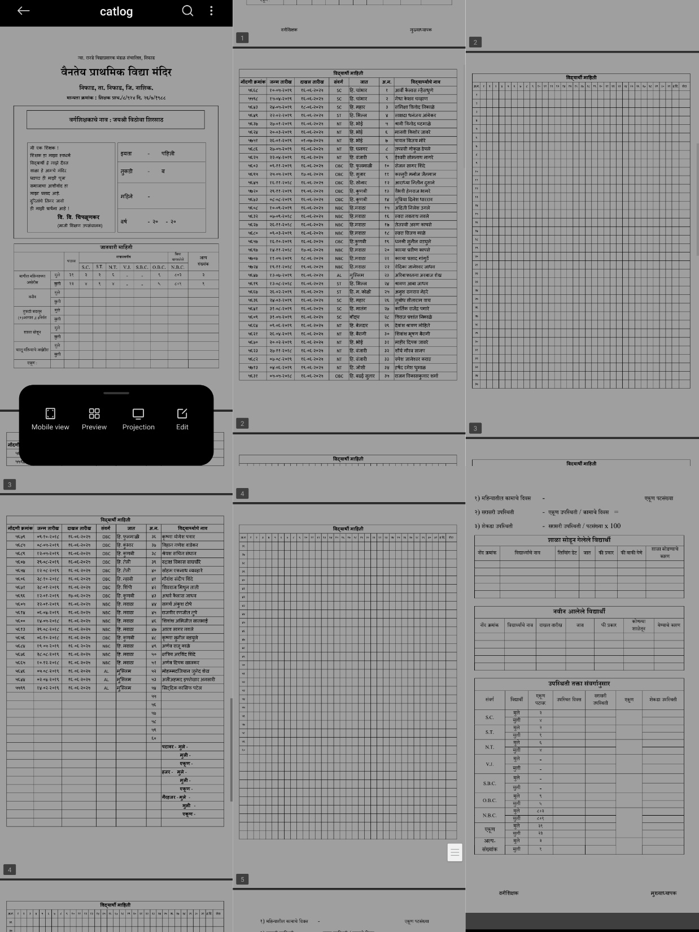
Tables on first and last page should be blank all other details should be filled
REPORT CARD MODULE
Printable report card format
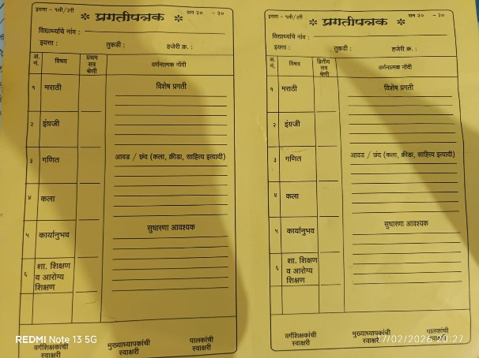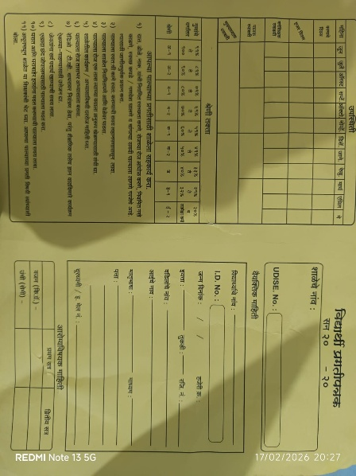

- School Profile: "वैनतेय प्राथमिक विद्या मंदिर" (Vainateya Prathamik Vidya Mandir).
- Short Name: वैनतेय
- Tagline: निफाड, नाशिक (Niphad, Nashik)
- Address: वैनतेय प्राथमिक विद्या मंदिर, निफाड, ता. निफाड, जि. नाशिक — 422303
- Trustee Line: न्या. रानडे विद्याप्रसारक मंडळ संचालित (Run by Nya. Ranade Vidyaprasarak Mandal).
- Offered Grades: इयत्ता १ ली ते ४ थी (Classes 1st to 4th Standard).
- Contact Number: +९१ २२ २३५६ ६८९० (Tel format: +91 22 2356 6890)
- General Email:

info@vainateya.edu
- Admissions Email:

admissions@vainateya.edu

